 | 10.1.6 Editors - Compositor Editor - Header - Add Menu - Input
Table of content
Detailed table of content 1
Add menu - Input 4
Constant – Sub Menu 4
Bokeh Image 5
Image 5
Mask 9
Movie Clip 9
Texture 11
Scene – Sub Menu 12

Detailed table of content

Detailed table of content
Detailed table of content 1
Add menu - Input 4
Constant – Sub Menu 4
RGB 4
Properties 4
Outputs 4
Color / RGBA 4
Value 4
Properties 4
Default Value 4
Outputs 4
Value 4
Bokeh Image 5
Properties 5
Flaps 5
Angle 5
Rounding 5
Catadioptric 5
Lens Shift 5
Outputs 5
Image 5
Image 5
Properties 6
Image Prop 6
List of images in the scene 6
Search form 6
Image Edit Box 6
Number of Fake Users 6
Fake User 6
Open 6
Remove 6
New 6
Name 7
Width 7
Height 7
Color 7
Alpha 7
Generated Type 7
32 Bit Float 7
Duplicate 7
Unlink Datablock 7
Fake User 7
Open Image 7
Unpack 8
User 8
Source 8
Color Space 8
Alpha 8
Outputs 8
Image 8
Alpha 8
Depth 8
Mask 9
Properties 9
Masks 9
Feather 9
Size Source 9
Motion Blur 9
Samples 9
Shutter 9
Outputs 9
Mask 9
Movie Clip 9
Properties 10
Movie Clip 10
File browser 10
Name 10
Fake User 10
Load File 10
Delete File 10
Outputs 10
Image 10
Alpha 10
Offset X 10
Offset Y 10
Scale 11
Angle 11
Texture 11
Inputs 11
Offset 11
Scale 11
Properties 11
Texture 11
Outputs 11
Value 11
Color 11
Scene – Sub Menu 12
Render Layers 12
Properties 12
Scene 12
Render layer 12
Outputs 12
Image 12
Alpha 12
Render passes sockets 12
Depth 13
Scene time 13
Outputs 13
Seconds 13
Frame 13
Time Curve 13
Properties 13
Navigation elements 13
Zoom in and out 13
Tools 14
Reset View 14
Extend Horizontal 14
Extend Extrapolated 14
Reset Curve 14
Use Clipping 14
Curve window 14
Selecting Points 14
Adding Points 14
Vector Handle 14
Auto Handle 14
Auto Clamped Handle 15
X and Y value edit box 15
Start / End 15
Delete Points 15
Outputs 15
Factor 15

Add menu - Input
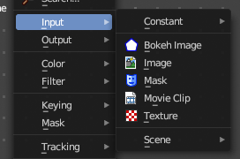
The Input menu contains Input node types.

The content is the same for all three sub modes. Note that you need to tick Use Nodes to activate the menu items when you are in Line Style sub mode.

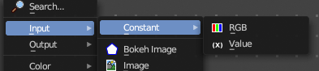
Constant – Sub Menu

The Constant Sub-menu contains Constant node types such as Value and RBG.

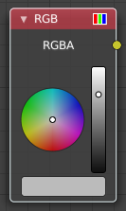
RGB
Set a color.

Properties
The RGB node uses the color picker widget.

Outputs

Color / RGBA
A single RGBA color value.

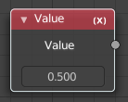
Value
The Value Node is a simple node to input numerical values to other nodes in the tree.

Properties

Default Value
Type in a single numerical value (floating point).

Outputs

Value
The value set in the options.

Bokeh Image
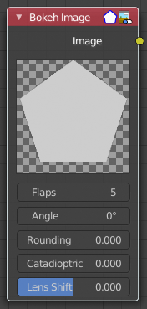
The Bokeh Image node generates a special input image for use with the Bokeh Blur filter node.
The Bokeh Image node is designed to create a reference image which simulates optical parameters such as aperture shape and lens distortions which have important impacts on bokeh in real cameras.

Properties
The first three settings simulate the aperture of the camera.

Flaps
Sets an integer number of blades for the cameras iris diaphragm.

Angle
Gives these blades an angular offset relative to the image plane.

Rounding
Sets the curvature of the blades with (0 to 1) from straight to bringing them to a perfect circle.

Catadioptric
Provides a type of distortion found in mirror lenses and some telescopes. This can be useful to produce a visual complex bokeh.

Lens Shift
Introduces chromatic aberration into the blur such as would be caused by a tilt-shift lens.

Outputs

Image
The generated bokeh image.

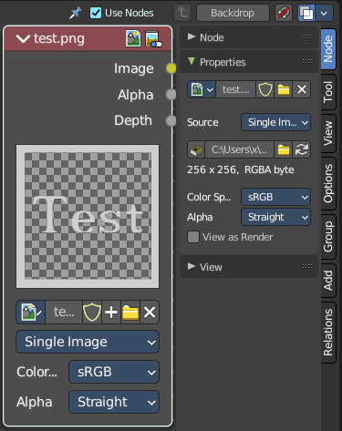
Image
Image input. For further image settings see also the Properties Panel in the Item Tab in the Sidebar.

Properties

Image Prop
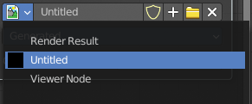
This property contains the list of loaded images. When no image is loaded then it displays the New and Open Buttons. When an image exists then it displays the name of the currently selected image.

From left to right ...

List of images in the scene
This is a list of the images in the scene. This list allows you to switch to other images.

Search form
Search for specific images.

Image Edit Box
Read the name of the currently selected image. And you can rename the image here too.

Number of Fake Users
In case this file has a fake user assigned, then this number displays the number of fake users.

Fake User
Wit this button you assign a fake user to this selected image.
Data, like images, that is not longer linked to anything else gets removed when you save and reload a scene. Bforartists has the concept of fake users to go around this behavior. An image with a fake user is in fact linked to something. And so it is not lost when you save and reload the scene.

Open
Open a new image.

Remove
Removes the image.

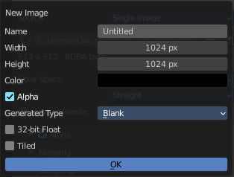
New
Create a new image.
Creates a new image. You will get a dialog where you can define settings for the new image.

Name
The name of the new image

Width
The width of the new image.

Height
The height of the new image.

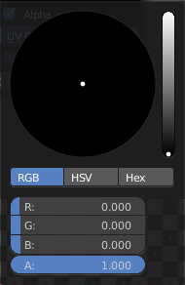
Color
Adjust the color of the new image. A click will call a color picker.

Alpha
Check this checkbox if the new image should have an alpha channel.

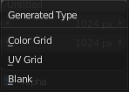
Generated Type
Here you can define what kind of texture you want to create.
Blank is one plain color.
UV Grid is a checker texture in black and white.
Color Grid is a colored checker texture.

32 Bit Float
Check this checkbox if the image should be in 32 Bit floating point bit depth per channel. Else it is in 8 bit per channel.

Duplicate
Not supported here.

Unlink Datablock
This deletes the selected image. Unfortunately not immediately. You need to save the scene and to reload it.
And you need to make sure that it is not linked to anything else. A mesh or a fake user for example. Have a look if there is a number besides the F button. When this is the case then the image has still a user, and so still loads with loading the scene.

Fake User
Wit this button you assign a fake user to this selected image.
Data, like images, that is not longer linked to anything else gets removed when you save and reload a scene. Bforartists has the concept of fake users to go around this behavior. An image with a fake user is in fact linked to something. And so it is not lost when you save and reload the scene.

Open Image
Opens the file browser to load an image.

Unpack
Unpack packed files to a directory.

User
The number of users that uses this data. Data with a user number of 0 will be removed with closing Bforartists.

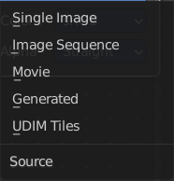
Source
What kind of image it is. The terms should be self explaining.

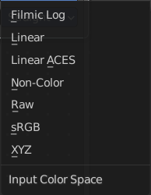
Color Space
What color space is used for the image.

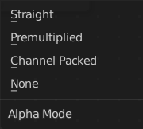
Alpha
What alpha mode is used for the image.

Outputs

Image
Standard image output.

Alpha
Separate Alpha value.

Depth
Z depth layer. This output just shows with specific image types.

Note. When a multi-layer file format, like EXR, is loaded, each layer is made available as a socket.

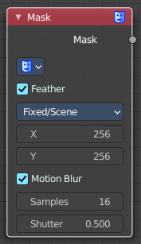
Mask
The Mask node can be used to select a Mask data. This node can be used with other nodes, for example to Invert, Multiply or Mix, or used as a factor input.
Masks can be created in the Image and Movie Clip editors, by changing the mode to Mask in the header. So you first need to create one in one of those editors.

Properties

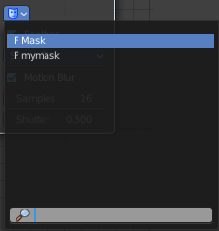
Masks
The available mask data. If the label is left blank, the mask name will be set.

Feather
Use or ignore feather points defined for splines see Mask Feathers for more details.

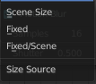
Size Source
Scene Size will give an image the size of the render resolution for the scene, scaling along when rendering with different resolutions. Fixed gives a fixed size in pixels. Fixed/Scene gives a size in pixels that still scales along when changing the render resolution percentage in the scene.

Motion Blur
For animated masks, creating a motion blurred mask from the surrounding frames, with a given number of samples (higher gives better quality), and a camera shutter time in seconds.

Samples
The number of motion blur samples.

Shutter
Expose for motion blur as a factor of Frames per Seconds.

Outputs

Mask
The black-and-white output of the mask.

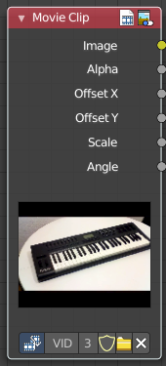
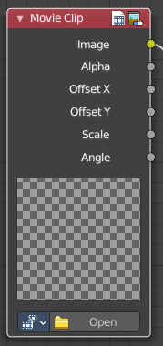
Movie Clip
This node is a special node that uses some of the values taken from footage cameras and trackings and links them to the output. It is possible to load image sequences, but only Image and Alpha values will be available, because the other outputs will not have any values associated with them. When a tracked clip is chosen, Blender will fulfill the outputs using internal values taken from the tracking. So the controls for start and end frames will be defined at the Movie Clip editor.

Properties

Movie Clip
Select the movie clip.
Once loaded you will see a preview image of the movie. Scrolling through the timeline will display the corresponding frame in this preview image.

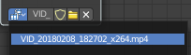
File browser
Choose an already loaded video.

Name
Read and edit the name of the video.

Fake User
Assign a fake user to this video. Fake users is an odd concept to keep data in the scene even if it has no user somewhere. The fake user is then a dummy user so that the object is not deleted when saving the scene.

Load File
Load a new video.

Delete File
Delete this video.

Outputs

Image
Outputs the entire image at the specified color space.

Alpha
The alpha value taken from the movie or image.

Offset X
The X offset value from the footage camera or tracking.

Offset Y
The Y offset value from the footage camera or tracking.

Scale
The scale of the image taken from the footage camera or tracking.

Angle
The lens angle taken from the footage camera or tracking.

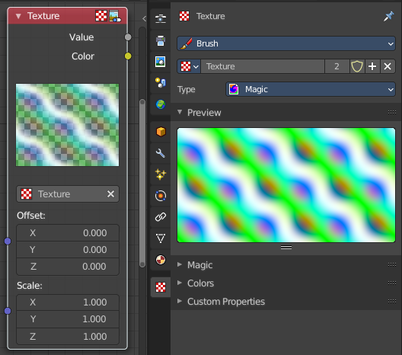
Texture
The Texture node allows you to use 3D textures in the Compositor. They can be created in the Texture tab in the Properties editor.

Inputs

Offset
A vector (XYZ) transforming the origin of the texture.

Scale
A vector (XYZ) to scale the texture.

Properties

Texture
The texture could be selected from a list of textures available in the current blend-file or link in textures. The textures themselves could not be edited in this note, but in the Texture panel.

Outputs

Value
Gray-scale color values.

Color
Color values.

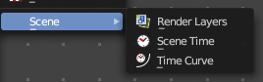
Scene – Sub Menu
The Scene Sub-menu contains scene node types such as Render Layers and Scene Time.

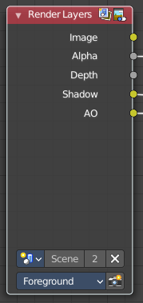
Render Layers
Inputs the available render layers.
This node is the starting place for getting a picture of your scene into the compositing node map.
The input happens through the properties.

Properties

Scene
Usually you don't need to select anything here when you work with just one Scene file. But in Bforartists you can work with more than one scene in a blend file. The scene information taken is the raw footage (pre-compositing and pre-sequencing).
Hint. To use composited footage from another scene, it has to be rendered into a multi-layer frame set (e.g. OpenEXR) as an intermediate file store and then imported with Image input node again.

Render layer
A list of available Render Layers. The render button allows you to re-render the active scene with one click.

Outputs

Image
The rendered image.

Alpha
The Alpha channel.

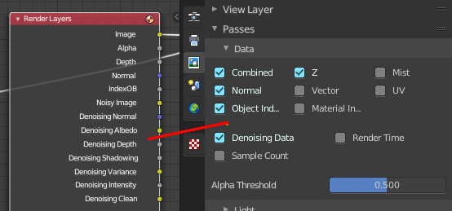
Render passes sockets
Depending on the Render passes that are enabled, other sockets are available. See Cycles and Eevee render passes. The Workbench renderer does not have extra render passes sockets. It just provides Image and Alpha output.

Depth
By default the Z depth pass is enabled.

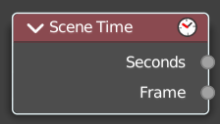
Scene time
Outputs the current scene time in seconds or in frames.
The Frame output is a float value to make subframe rendering for motion
blur possible.

Outputs

Seconds
Output in seconds.

Frame
Output in Frames.

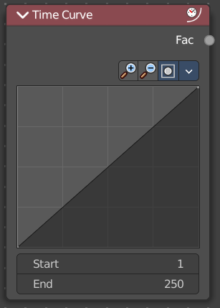
Time Curve
The Time node generates a factor value that changes according to the curve as time progresses through the Timeline. The range goes from 0.0 to 1.0. The default is a linear line from 0.0 to 1.0. But the curve can be adjusted.

Properties

Navigation elements
The navigation elements for the curve. They are described from left to right.

Zoom in and out
The two buttons with the magnifying glass at it zooms in and out in the curve window.

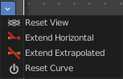
Tools
Tools is a menu where you can find some curve related tools.

Reset View
Resets the curve windows zoom.

Extend Horizontal
Extends the curve horizontally before the first point and behind the last point.

Extend Extrapolated
Extends the curve extrapolated before the first point and behind the last point.

Reset Curve
Resets the curve to the initial shape.

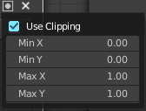
Use Clipping
Clipping options. Set up clipping for the stroke.

Curve window
Tweak and adjust the falloff curve by clicking at a curve point and dragging it around.
Double click adds a new point.
Holding down ctrl activates temporary snapping.
Holding down shift enables slower movement, which allows more accurate setting.

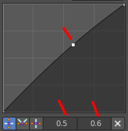
Selecting Points
You can select curve points. This reveals two edit boxes for the x and y coordinate of this point.
Selected points can be moved around. Left click at them, hold the mouse button down and move them to a new location.

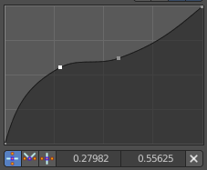
Adding Points
You can add new curve points by simply left clicking at the curve. Move the mouse to position them where you need it.

Vector Handle
Set handle type to Vector.

Auto Handle
Set handle type to Auto.

Auto Clamped Handle
Set handle type to Auto Clamped.

X and Y value edit box
The X and Y value for the currently selected curve point.

Start / End
Start frame and End frame of the range of time specifying the values the output should last. This range becomes the X axis of the graph. The time input could be reversed by specifying a start frame greater than the end frame.

Delete Points
Deletes selected curve points.

Outputs

Factor
A speed of time factor (from 0.00 to 1.00) relative to the frame rate defined in the Render Dimensions Panel. The factor changes according to the defined curve.
Hint. By using curves it is possible that the Time node may output a number larger than one or less than zero. To be safe, you should use the Min/Max clamping function of the Map Value node to limit output.

